Setting Up the D-Star Repeater as a Split Repeater

# Introduction

The idea behind the Split mode of the D-Star Repeater is to allow more than one set of transmitters and receivers to be combined to provide a repeater with better transmit and receive coverage while acting as one repeater. The Split driver will choose the best receiver for each 20ms slice of audio data based on the quality of the received data and not simply the strongest signal.

The receivers will either be based at separate sites (Site Diversity) or on one site but using different antennae (Space Diversity).

# The Sample Configuration

For the sake of this document I will assume a very diverse system, incorporating two receivers, two transmitters, and two combined transmitters and receivers. In each case one will be based on a remote site, or at least a separate computer, and the other running on the same computer as the D-Star Repeater operating as the Split repeater. This configuration is not possible to achieve in reality because there are not enough transmitter slots in the software, but the principle is still good.

Each transmitter, receiver, and transmit/receiver has to be allocated a unique name, for this example I will choose RX1 for the local receiver, RX2 for the external receiver, TX1 for the local transmitter, TX2 for the external transmitter, TRX1 for the local transmitter/receiver, and TRX2 for the external transmitter/receiver. For clarification a transmitter/receiver site is standard full duplex D-Star repeater with one modem, however the data that is transmitted is not necessarily linked to the data that is being received.

The reality will usually be somewhat simpler than this, with fewer transmitters and receivers. An example would be a 10m D-Star repeater which would consist of one transmitter and one receiver site, physically separated to provide the required RF isolation. Another option would be the main site with a transmitter/receiver with a separate receive site to provide better receiver coverage within a city.

The screenshots shown are from a system running on Windows 8.1 but are applicable to all Windows and Linux versions.

## Gateway and Split D-Star Repeater Configuration

This is probably the simplest part of the configuration. Apart from the modem configuration, the D-Star Repeater configuration is standard, as seen below.

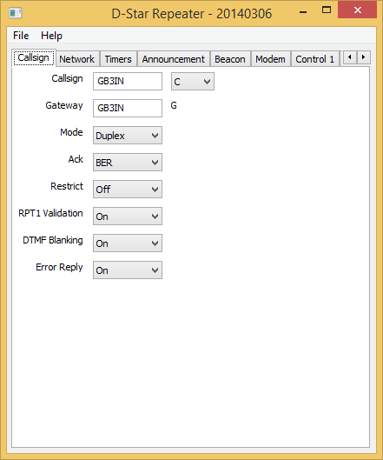

The only thing to mention here is that the Split version of the D-Star Repeater must have a mode of Duplex.

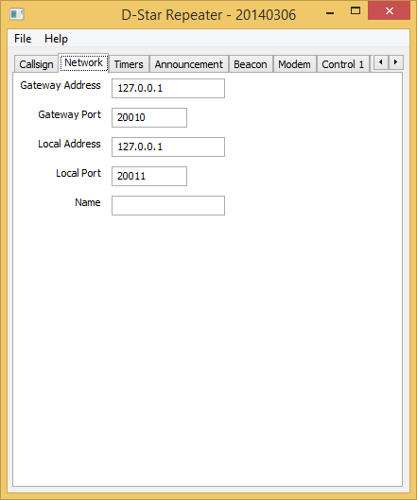

The network configuration is also standard. The above screen shot assumes that the gateway and Split version of the D-Star Repeater both reside on the same computer hence the use of 127.0.0.1 as the addresses to limit the visibility and hence increase the security of the system. The choice of 20010 and 20011 for the ports is arbitrary, but seems to have become a standard, they may be anything as long as they don’t clash with something else on the same computer.

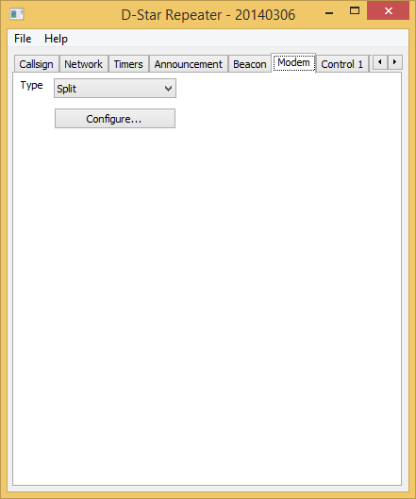

The modem type is set to Split, and the Configure… button is pressed, to bring up the Split configuration screen.

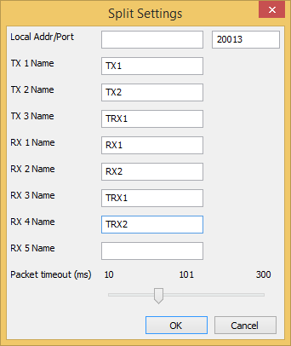

As described earlier the different transmitters are receivers have unique names and they appear in this dialogue. The transmit/receive sites appear in both the TX and RX Names section, while the receive sites appear only in the RX Name section, and the transmit sites in the TX Name section. TRX2 is missing in the TX Name section due to a lack of space.

If all of the transmitters, receivers, or transmitter/receivers are operating on the same computer then the Local Addr can be set to 127.0.0.1, otherwise it should be left blank. The Local Port should be set to a value that is not already used, 20012 would have been fine in this example (20010 and 20011 are already in use), but 20013 was chosen. This value can be almost anything as long as it doesn’t clash with another use on your computer.

The Packet timeout is used to allow the Split portion to wait long enough to receive all of the data from the different receivers before choosing the best one. This value must be determined by trial and error, and statistics logged by the Split portion of the repeater will be useful in determining the best value. Too short and data will be ignored, too long and unnecessary delays will be introduced into the system.

For the sake of completeness, here is the gateway portion of the configuration.

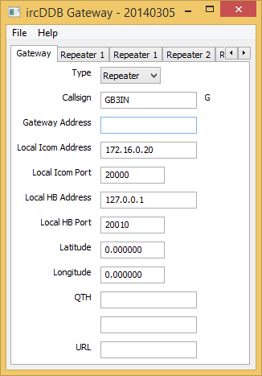

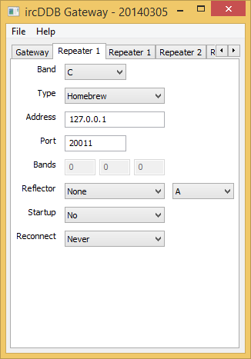

## The Receiver Sites

The configuration of the receiver sites is almost identical with each other. The Callsign screen is identical between them.

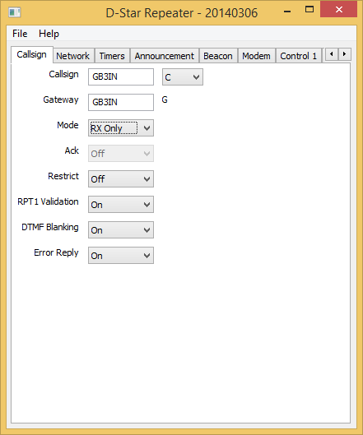

Note that the Mode is set to RX Only. The Callsign and Gateway are set to the same as the Split part of the repeater, but this is probably not necessary. This mode will ensure that no transmit data is sent to the modem so, for example, a DVAP could be used as a receiver at a remote site quite happily.

The real differences are with the Network settings. First the receiver that is running on the same computer as the Split portion.

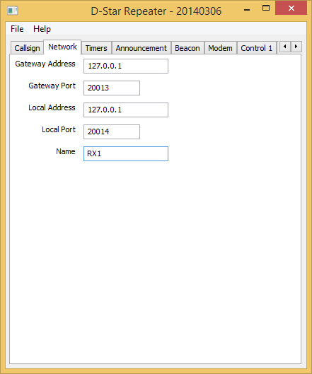

Since it is on the same computer, the addresses are set to 127.0.0.1, the Gateway Port (somewhat misnamed here) is set to the Local Port on the Split Settings above. The Local Port here must also be unique value for that computer; I have chosen 20014 as it is the next in the sequence. The name RX1 is listed in the Split Settings in the RX Name section.

The Network settings for the distant receiver system is more complex.

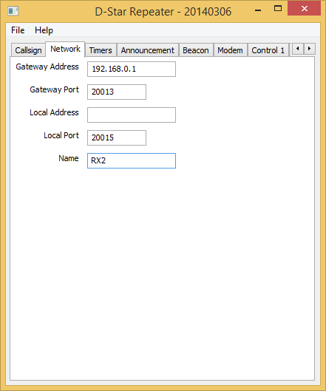

The Gateway Port and the Name are straightforward, being the port of the Split portion, and the name is that of the external receiver. The Local Address is blank as it has to be able to talk to the outside world and not just on the local computer. The Local Port has to be unique on the computer on which it is running, in this case I chose the next number, however this is not necessary and you could 20010 again as it is on a different machine and therefore won’t clash with the other use of 20010 shown earlier. The Gateway Address is the publically visible address of the Split part of the system, and will typically be a real Internet address, unless you have a private network. You will probably have to configure the router at both ends in order to enable it to pass the data reliably.

## The Transmitter Sites

The configuration of the transmitter sites is almost identical with each other. The Callsign screen is identical between them.

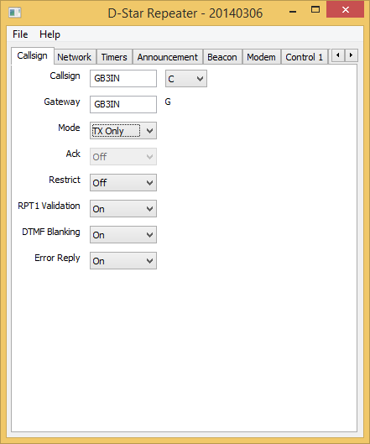

Note that the Mode is set to TX Only. The Callsign and Gateway are set to the same as the Split part of the repeater, but this is probably not necessary. This mode will ensure that no receive data is taken from the modem.

The real differences are with the Network settings. First the transmitter that is running on the same computer as the Split portion.

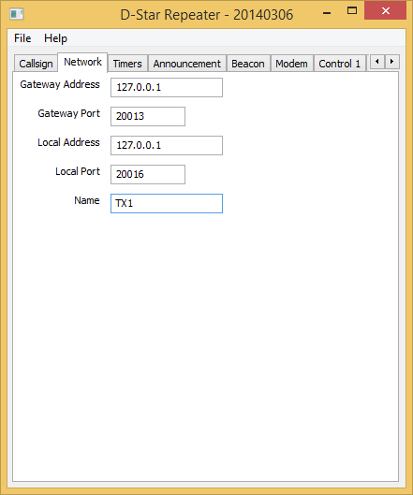

Since it is on the same computer, the addresses are set to 127.0.0.1, the Gateway Port (somewhat misnamed here) is set to the Local Port on the Split Settings above. The Local Port here must also be unique value for that computer; I have chosen 20016 as it is the next in the sequence. The name TX1 is listed in the Split Settings in the TX Name section.

The Network settings for the distant transmitter system is more complex.

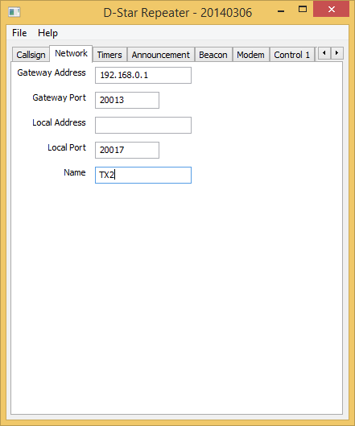

The Gateway Port and the Name are straightforward, being the port of the Split portion, and the name is that of the external receiver. The Local Address is blank as it has to be able to talk to the outside world and not just on the local computer. The Local Port has to be unique on the computer on which it is running, in this case I chose the next number, however this is not necessary and you could 20010 again as it is on a different machine and therefore won’t clash with the other use of 20010 shown earlier. The Gateway Address is the publically visible address of the Split part of the system, and will typically be a real Internet address, unless you have a private network. You will probably have to configure the router at both ends in order to enable it to pass the data reliably.

## The Transmitter/Receiver Sites

The configuration of the transmitter/receiver sites is almost identical with each other. The Callsign screen is identical between them.

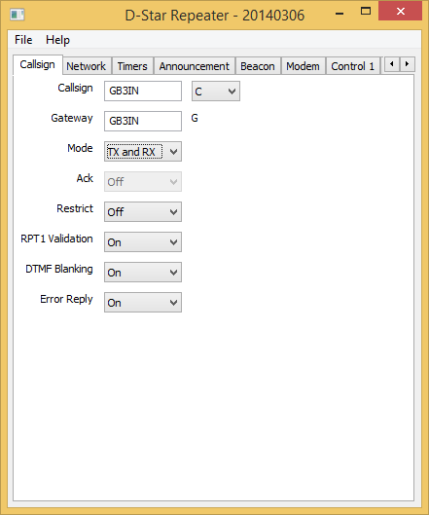

Note that the Mode is set to TX and RX. The Callsign and Gateway are set to the same as the Split part of the repeater, but this is probably not necessary.

The real differences are with the Network settings. First the transmitter/receiver that is running on the same computer as the Split portion.

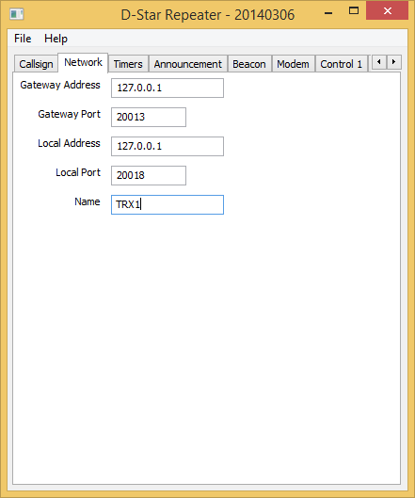

Since it is on the same computer, the addresses are set to 127.0.0.1, the Gateway Port (somewhat misnamed here) is set to the Local Port on the Split Settings above. The Local Port here must also be unique value for that computer; I have chosen 20018 as it is the next in the sequence. The name TRX1 is listed in the Split Settings in the TX Name and RX Name sections. Note that TRX2 doesn’t appear in the TX Name section in this example, however this merely down to space reasons.

The Network settings for the distant transmitter/receiver system is more complex.

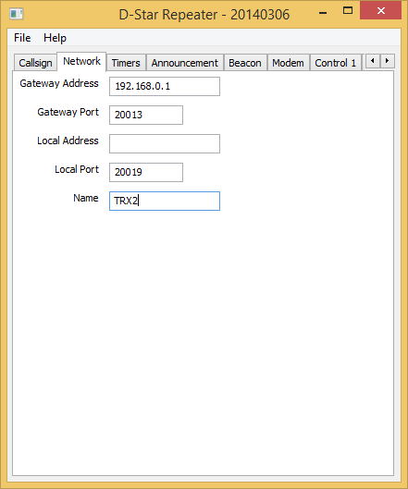

The Gateway Port and the Name are straightforward, being the port of the Split portion, and the name is that of the external receiver. The Local Address is blank as it has to be able to talk to the outside world and not just on the local computer. The Local Port has to be unique on the computer on which it is running, in this case I chose the next number, however this is not necessary and you could 20010 again as it is on a different machine and therefore won’t clash with the other use of 20010 shown earlier. The Gateway Address is the publically visible address of the Split part of the system, and will typically be a real Internet address, unless you have a private network. You will probably have to configure the router at both ends in order to enable it to pass the data reliably.

# Running the System

The D-Star Repeater in Split mode and the external Transmitters, Receivers, and Transmitters/Receivers are run in the standard way, and the document detailing the D-Star Repeater should be consulted about that. The only extra thing to note is that the Splt repeater system will only be fully operational once all of the external system have registered with the repeater in Split mode. This will appear in the log similar to:

M: 2014-03-10 20:04:18: Registration of RX 1 "RX1" set to 127.0.0.1:20012

M: 2014-03-10 20:04:28: Registration of TX 1 "TX1" set to 127.0.0.1:20016

These registration messages are sent every thirty seconds and the first one ten seconds after the repeater program has started.

# Questions?

The Yahoo! group pcrepeatercontroller has hundreds of subscribers who use this software, and asking a question their will often provide an answer for anything that is not covered in this document. The group also has a search function so that you can search for someone else asking the same question earlier. If you run any of the software described here, then it is recommended that you join the group, it can be found at <http://groups.yahoo.com/group/pcrepeatercontroller/>.

# Revision History

|  |  |  |
| --- | --- | --- |
| Date | Description | Author |
| 2014-03-07 | First version. | Jonathan Naylor, G4KLX |
| 2014-03-12 | Revision and clean ups. | Jonathan Naylor, G4KLX |
|  |  |  |

# Document Licence

This document is released under the Creative Commons Public Licence.



### You are free:

* **to Share** — to copy, distribute and transmit the work
* **to Remix** — to adapt the work

### Under the following conditions:

* **Attribution** — You must attribute the work in the manner specified by the author or licensor (but not in any way that suggests that they endorse you or your use of the work).
* **Non Commercial** — You may not use this work for commercial purposes.
* **Share Alike** — If you alter, transform, or build upon this work, you may distribute the resulting work only under the same or similar license to this one.

You can find further information at:

<http://creativecommons.org/licenses/by-nc-sa/3.0/>

<http://creativecommons.org/licenses/by-nc-sa/3.0/legalcode>